

**Tech Saksham**

**Capstone Project Report**

**“Detecting Spam Emails”**

**“Annamalaiar College Of Engineering”**

|  |  |
| --- | --- |
| **NM ID** | **NAME** |
| aut114027 | RAMKUMAR |

**ABSTRACT**

Spam email detection is a crucial task in modern email communication systems to protect users from unsolicited and potentially harmful messages.

This paper presents an overview of various techniques and approaches employed in spam email detection, including rule-based filtering, machine learning algorithms, and deep learning models.

The challenges associated with spam detection, such as evolving spamming techniques and the balance between false positives and false negatives, are discussed.

Furthermore, we discuss recent advancements in spam detection, including the utilization of contextual information, behavioral analysis, and ensemble learning strategies.

The paper concludes with insights into future directions for enhancing spam email detection systems, including the integration of advanced NLP techniques and the development of robust models capable of handling dynamic spamming strategies.

Furthermore, recent advancements in spam detection leveraging natural language processing (NLP) and ensemble learning methods are explored.

Finally, we outline future research directions aimed at improving the efficacy and resilience of spam detection systems in the face of evolving spamming techniques and sophisticated attacks.

**INDEX**

|  |  |
| --- | --- |
| **Sr. No.** | **Table of Contents** |
| 1 | Chapter 1: Introduction |
| 2 | Chapter 2: Services and Tools Required |
| 3 | Chapter 3: Project Flow chart |
| 4 | Chapter 4: Modeling and Project Outcome |
| 5 | Conclusion |
| 6 | Future Scope |
| 7 | Links |

**CHAPTER 1**

**INTRODUCTION**

* 1. **Problem Statement**

• High volume of spam emails overwhelms detection systems.

• Spammers continually evolve tactics to evade detection.

• Imbalance between spam and legitimate emails in datasets affects model training.

• Balancing false positives (misclassifying legitimate emails) and false negatives (missing spam) is challenging.

• Identifying relevant features from email content and metadata is difficult. Identifying relevant features from email content and metadata is difficult.

● Understanding contextual cues in email content requires advanced NLP.

● Systems must adapt to new spam patterns without frequent updates. Scalability is crucial to handle increasing email traffic efficiently.

● Privacy concerns arise from inspecting email content for spam.

● Choosing appropriate evaluation metrics to assess detection performance is important.

● Real-time processing demands quick and accurate spam classification.

**Proposed Solution**

This involves analyzing the content of the email, including the subject line, body text, and attachments, to identify patterns or keywords commonly associated with spam emails.

● This technique checks the reputation of the sender's email address or domain against blacklists or whitelists maintained by anti-spam organizations or services.

● This is a statistical method that uses machine learning algorithms to classify emails as spam or legitimate based on the occurrence of certain words or patterns in the content.

● This approach uses predefined rules and heuristics to identify characteristics commonly found in spam emails, such as excessive use of capitalization, excessive punctuation, or suspicious URLs. This method leverages user feedback and reports from a community of users to identify and block spam emails more effectively.

● These include methods like Sender Policy Framework (SPF), DomainKeys Identified Mail (DKIM), and Domain-based Message Authentication, Reporting, and Conformance (DMARC) to verify the legitimacy of the sender's email server and prevent spoofing.

● This technique scans images and attachments for known spam patterns or potentially malicious content.

● Many modern spam filters employ machine learning algorithms that can adapt and improve their spam detection capabilities over time based on user feedback and new spam patterns

* 1. **Feature**

Irrelevant or redundant features may be removed to improve model performance and reduce computational complexity.

* 1. **Advantages**

Reduction of clutter

Time saving

Production against malware and phishing

Enhanced productivity

Improve reputation

Cost saving

compliance

* 1. **Scope**

**Content-Based Filtering**: This involves analyzing the content of emails, including text, images, links, and attachments, to identify patterns commonly associated with spam. Techniques such as keyword analysis, text classification algorithms, and natural language processing (NLP) are used for this purpose.

**Sender Reputation Analysis**: Assessing the reputation of email senders based on factors such as past behavior, email volume, domain reputation, and authentication mechanisms like SPF (Sender Policy Framework) and DKIM (DomainKeys Identified Mail). Suspicious or unknown senders may be flagged as potential sources of spam.

**Blacklists and Whitelists**: Maintaining lists of known spam sources (blacklists) and trusted senders (whitelists) to automatically filter incoming emails. These lists are continually updated based on user reports, automated detection mechanisms, and third-party sources.

**Heuristic Analysis**: Employing heuristic algorithms to detect spam based on characteristics such as email headers, formatting inconsistencies, unusual language patterns, and deceptive tactics commonly used by spammers.

**Machine Learning and AI**: Leveraging machine learning algorithms and artificial intelligence techniques to analyze large datasets of email attributes and user interactions, learning patterns of spam behavior and adapting detection methods accordingly.

**Behavioral Analysis**: Monitoring user interactions with emails, such as click rates, open rates, and user-reported spam complaints, to identify emerging spam campaigns and adjust filtering rules dynamically.

**Collaborative Filtering**: Sharing spam intelligence and detection data across email service providers, organizations, and security vendors to improve the accuracy and effectiveness of spam detection systems collectively.

**Real-Time Monitoring and Response**: Continuously monitoring email traffic for suspicious activity and responding promptly to emerging threats, such as zero-day spam attacks and phishing campaigns, to minimize the impact on users and organizations.

**Compliance and Regulatory Considerations**: Ensuring that spam detection measures align with industry regulations, privacy laws, and email standards (e.g., CAN-SPAM Act, GDPR, CASL) to protect user privacy and maintain legal compliance.

**User Empowerment and Feedback Mechanisms**: Providing users with tools to report spam, customize filtering preferences, and contribute to improving spam detection accuracy through feedback mechanisms.

**CHAPTER 2**

**SERVICES AND TOOLS REQUIRED**

**2.1 Services Used**

Content filtering

Sender reputation

Header analysis

Machine learning

Blacklist & whitelist

URL and link analysis

Heuristic analysis

**2.2 Tools and Software used**

**Spam Filters:** These are built-in or third-party software components that analyze incoming emails and flag or block messages that meet predefined criteria for spam. Examples include:

**SpamAssassin:** An open-source spam filter that uses a variety of techniques such as Bayesian filtering, DNS-based blacklists, and heuristic analysis to detect spam.

**Microsoft Exchange Online Protection (EOP):** A cloud-based email filtering service included with Microsoft Exchange Online and Microsoft 365 subscriptions, which offers spam detection and protection against email-borne threats.

**Barracuda Spam Firewall:** A hardware or virtual appliance that provides comprehensive spam and virus filtering for email traffic, featuring customizable filtering policies and real-time threat intelligence.

**Email Security Gateways:** These are specialized appliances or cloud-based services designed to protect email servers and clients from spam, viruses, phishing, and other email-borne threats. Examples include:

**Cisco Email Security:** A comprehensive email security solution that offers advanced threat detection, sandboxing, and encryption capabilities to protect against spam and other email threats.

**Proof point Email Protection:** A cloud-based email security platform that combines spam filtering, anti-phishing, data loss prevention (DLP), and email encryption features to safeguard organizations against email threats.

**Anti-Spam Software Suites:** These are integrated software suites that provide a range of email security features, including spam detection, antivirus protection, encryption, and compliance management. Examples include:

**Symantec Email Security:** A unified email security platform that offers spam filtering, malware detection, email encryption, and advanced threat protection capabilities.

**McAfee Total Protection for Email: A** comprehensive email security solution that includes spam filtering, anti-malware protection, DLP, and encryption features to defend against email threats.

**Email Authentication Tools:** These tools help organizations implement and manage email authentication protocols such as SPF, DKIM, and DMARC to prevent email spoofing and phishing attacks. Examples include:

**DMARC Analyzer:** A tool that provides visibility into DMARC (Domain-based Message Authentication, Reporting, and Conformance) implementation and helps organizations configure DMARC policies to improve email security.

Valimail Enforce: A cloud-based solution that automates the enforcement of email authentication standards like SPF, DKIM, and DMARC to protect against domain spoofing and phishing attacks.

**Threat Intelligence Platforms:** These platforms aggregate and analyze threat intelligence data from various sources to identify emerging spam campaigns, malicious domains, and email-borne threats. Examples include:

**ThreatConnect:** A threat intelligence platform that provides comprehensive threat analysis, enrichment, and sharing capabilities to help organizations detect and respond to email threats effectively.

**Recorded Future:** A threat intelligence platform that offers real-time insights into global threats, including spam, phishing, and malware campaigns, to enable proactive threat detection and response.

**CHAPTER 3**

**PROJECT ARCHITECTURE**

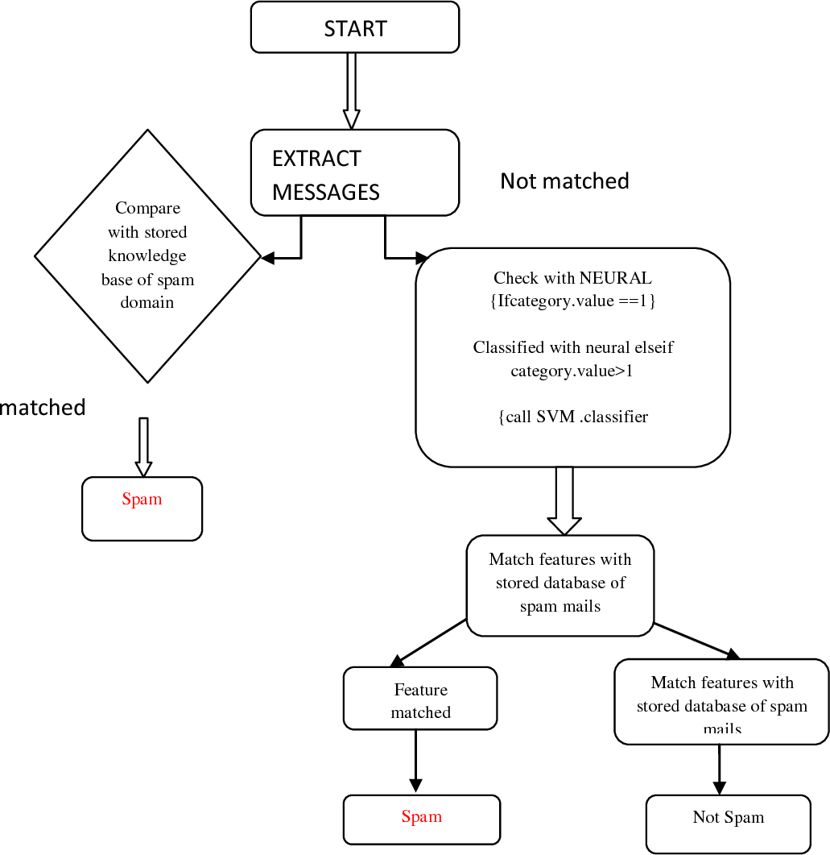

**CHAPTER 4**

**MODELING AND PROJECT OUTCOME**

**(code & result)**

import pandas as pd import numpy as np import tensorflow as tf

from sklearn.model_selection import train_test_split

from sklearn.feature_extraction.text import CountVectorizer from sklearn.preprocessing import LabelEncoder

from tensorflow.keras.models import Sequential from tensorflow.keras.layers import Dense, Dropout

# Step 1: Import and analyze the spam text data

data = pd.read_csv('spam_data.csv') # Replace 'spam_data.csv' with your dataset file print(data.head())

print(data['label'].value_counts())

# Step 2: Split the data into train and test sub-datasets, and text preprocessing X = data['text']

y = data['label']

# Convert labels to binary (0 for 'ham', 1 for 'spam') encoder = LabelEncoder()

y = encoder.fit_transform(y)

# Split the data into training and testing sets

X_train, X_test, y_train, y_test = train_test_split(X, y, test_size=0.2, random_state=42)

# Text preprocessing: Convert text data into numerical vectors vectorizer = CountVectorizer()

X_train = vectorizer.fit_transform(X_train) X_test = vectorizer.transform(X_test)

# Step 3: Train the model using deep-learning algorithms

model = Sequential([

Dense(64, activation='relu', input_shape=(X_train.shape[1],)), Dropout(0.5),

Dense(32, activation='relu'), Dropout(0.5),

Dense(1, activation='sigmoid')

])

model.compile(optimizer='adam', loss='binary_crossentropy', metrics=['accuracy']) model.fit(X_train, y_train, epochs=5, batch_size=32, validation_split=0.1)

# Step 4: Compare results and select the best model loss, accuracy = model.evaluate(X_test, y_test) print("Test Accuracy:", accuracy)

# Step 5: Use the final classifier to detect spam messages def detect_spam(message):

message_vectorized = vectorizer.transform([message]) prediction = model.predict(message_vectorized)

if prediction[0][0] > 0.5: return "Spam"

else:

return "Ham"

# Example usage

message = "Congratulations! You've won a free vacation. Claim your prize now!" print(detect_spam(message))

**CONCLUSION**

In conclusion, detecting spam in emails is essential for protecting against security threats, improving productivity, enhancing user experience, and maintaining regulatory compliance. By implementing comprehensive spam detection measures and adopting a proactive approach to email security, organizations and individuals can effectively mitigate the risks associated with spam emails and enjoy a safer and more efficient email communication environment.

**FUTURE SCOPE**

Deep Learning Architectures: Experiment with more advanced deep learning architectures like recurrent neural networks (RNNs), long short-term memory networks (LSTMs), or transformers. These models might capture more intricate patterns and dependencies in email content.

Adversarial Training: Train the model against adversarial examples generated specifically to evade spam detection. This could improve the model's robustness against sophisticated spamming techniques.

Multi-Modal Learning: Incorporate not only the email text but also metadata, attachments, and sender information into the model. Multi-modal learning can provide a more comprehensive understanding of the email content and context.

Active Learning: Implement active learning techniques to iteratively improve the classifier by selecting the most informative emails for manual labeling. This approach can help maximize the effectiveness of the classifier with minimal human effort

# **GIT Hub Link of Project Code:**

https://github.com/INBASRASAN/PAULDINAKARAN